

SCHOOL OF COMPUTER ENGINEERING AND INFORMATION SYSTEM

DEPARTMENT: SOFTWARE ENGINEERING

NAME: VIGNESHWARAN T

REG NO: 23MIS0587

COURSE NAME: Agile Development Process and
Devops Lab

COURSE CODE: ISWE406P

SLOT: L3 + L4

DIGITAL ASSIGNMENT – IV

(Automated CI/CD Pipeline: Deploying a Web Application using Jenkins, Docker, and Kubernetes)

Create an HTML file for your profile and complete the following:
1. Create a repository in GIT and create the following files:
• index.html
• Dockerfile
• Deployment.yaml

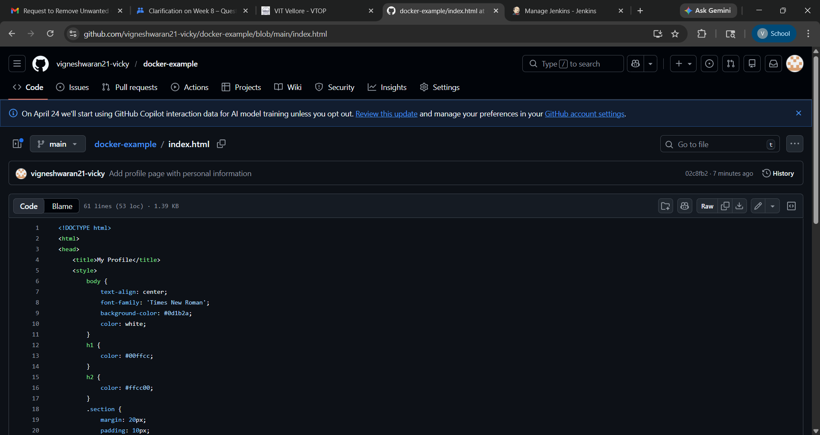

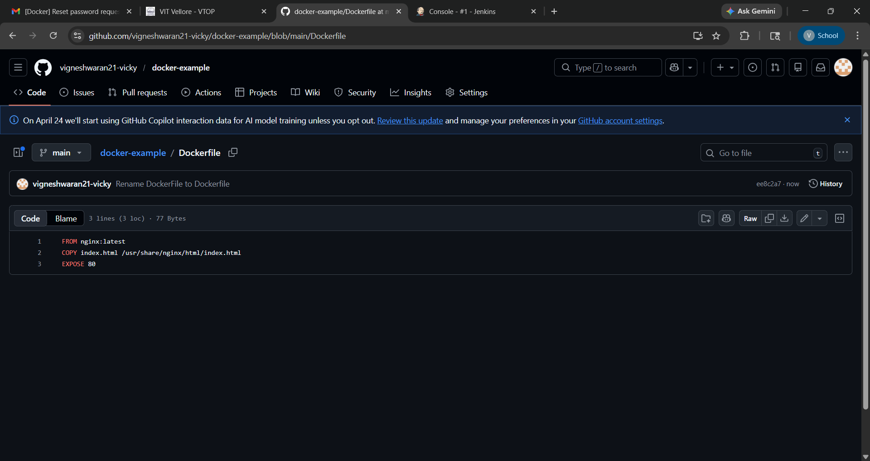

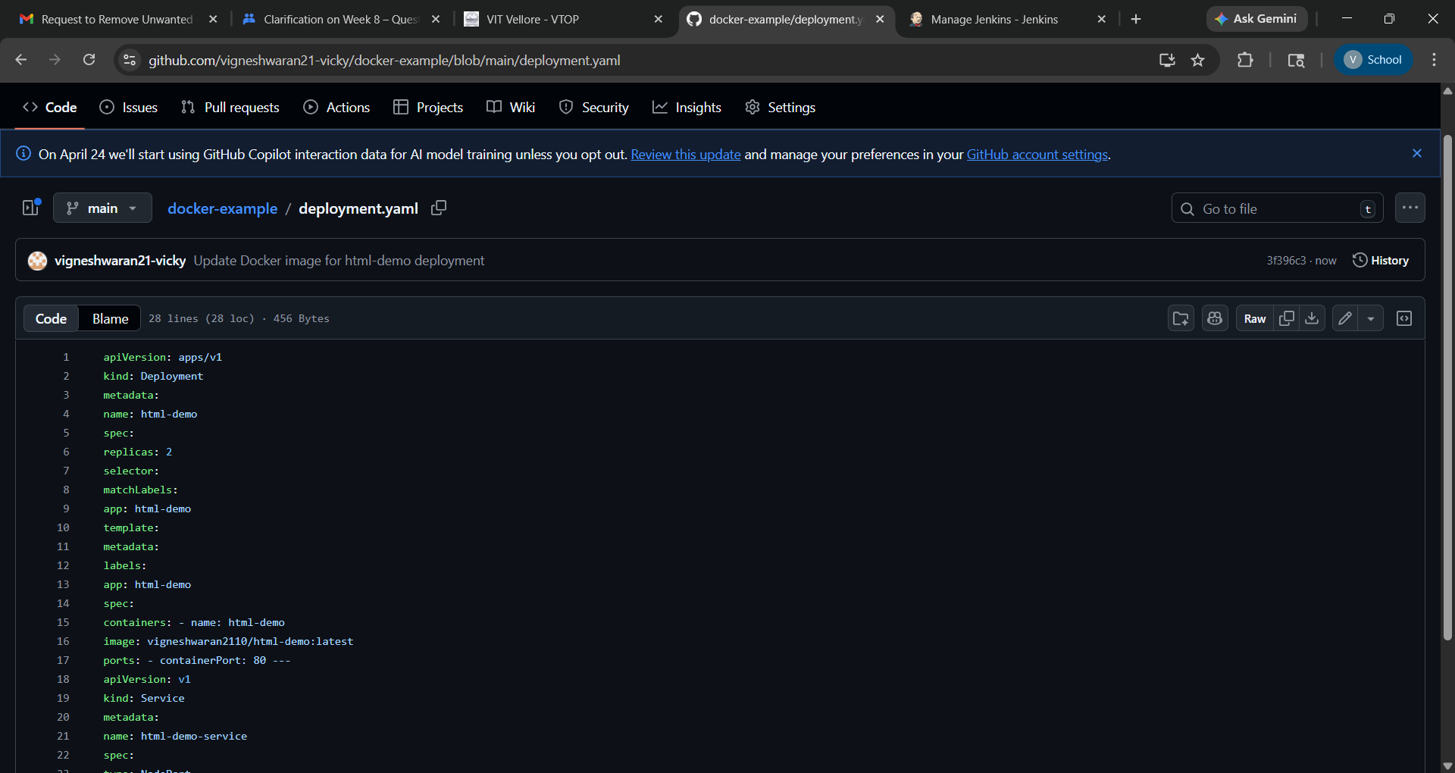

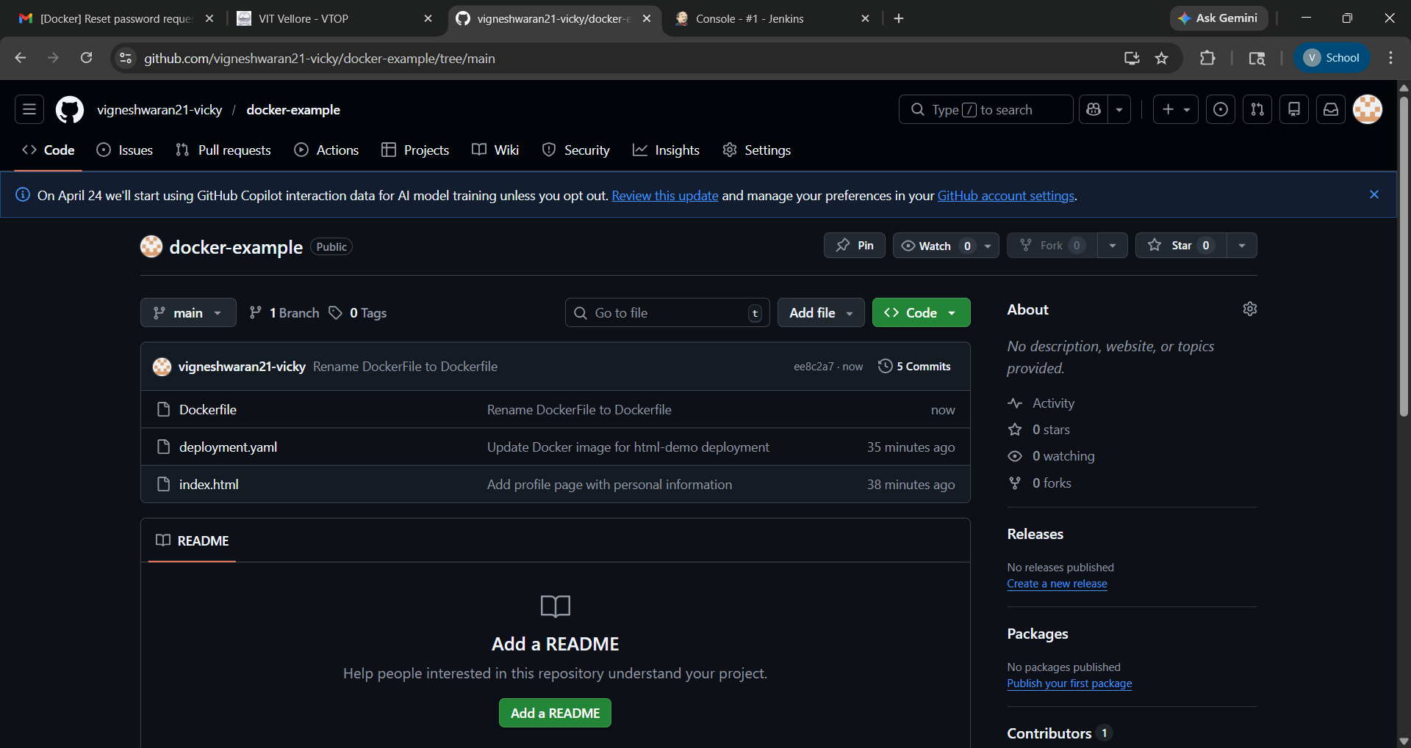

The code for the three files are given below:
Create index.html:

<!DOCTYPE html>
<html>
<head>
<title>My Profile</title>
<style>
body {
text-align: center;
font-family: 'Times New Roman';
background-color: #0d1b2a;
color: white;
}
h1 {
color: #00ffcc;
}
h2 {
color: #ffcc00;
}
.section {
margin: 20px;
padding: 10px;
}
</style>
</head>

<body>

<h1>My Profile</h1>
<h2>Vigneshwaran T</h2>

<div class="section">
<h3>Education</h3>
<p>M.Tech Integrated Software Engineering</p>
</div>

<div class="section">
<h3>About Me</h3>
<p>
I am a passionate software engineering student with strong interest in
development, data science, and innovative technologies. I enjoy building
real-world applications and continuously learning new skills.
</p>
</div>

<div class="section">
<h3>Achievements</h3>
<p>✔ Published 2 Patents</p>
<p>✔ Participated in technical projects and research activities</p>
</div>

<div class="section">
<h3>Skills</h3>
<p>Python, Machine Learning, Web Development, Data Analysis</p>
</div>

<div class="section">
<h3>Contact</h3>
<p>Email: vigneshwaran.2023b@vitstudent.ac.in</p>
</div>

</body>
</html>

Create a Dockerfile

FROM nginx:latest
COPY index.html /usr/share/nginx/html/index.html
EXPOSE 80

deployment.yaml:

apiVersion: apps/v1
kind: Deployment
metadata:
name: html-demo
spec:
replicas: 2
selector:
matchLabels:
app: html-demo
template:
metadata:
labels:
app: html-demo
spec:
containers:
- name: html-demo
image: vigneshwaran2110/html-demo:latest
ports:
- containerPort: 80

---
apiVersion: v1
kind: Service
metadata:
name: html-demo-service
spec:
type: NodePort
selector:
app: html-demo
ports:
- port: 80
targetPort: 80
nodePort: 30010

2. Enable Kubernetes
- Open the Docker Dashboard: Launch the Docker Desktop application on your system.
- Navigate to Settings: Click the gear icon (Settings or Preferences) in the top-right or sidebar of the Docker Dashboard.
- Select the Kubernetes Tab: In the Settings menu, find and select the Kubernetes tab.
- Enable Kubernetes: Check the box labeled Enable Kubernetes.
- Apply & Restart: Click the Apply & Restart button at the bottom of the settings window.
- Docker Desktop will then download the necessary Kubernetes components and start a single-node cluster. This may take a few minutes the first time
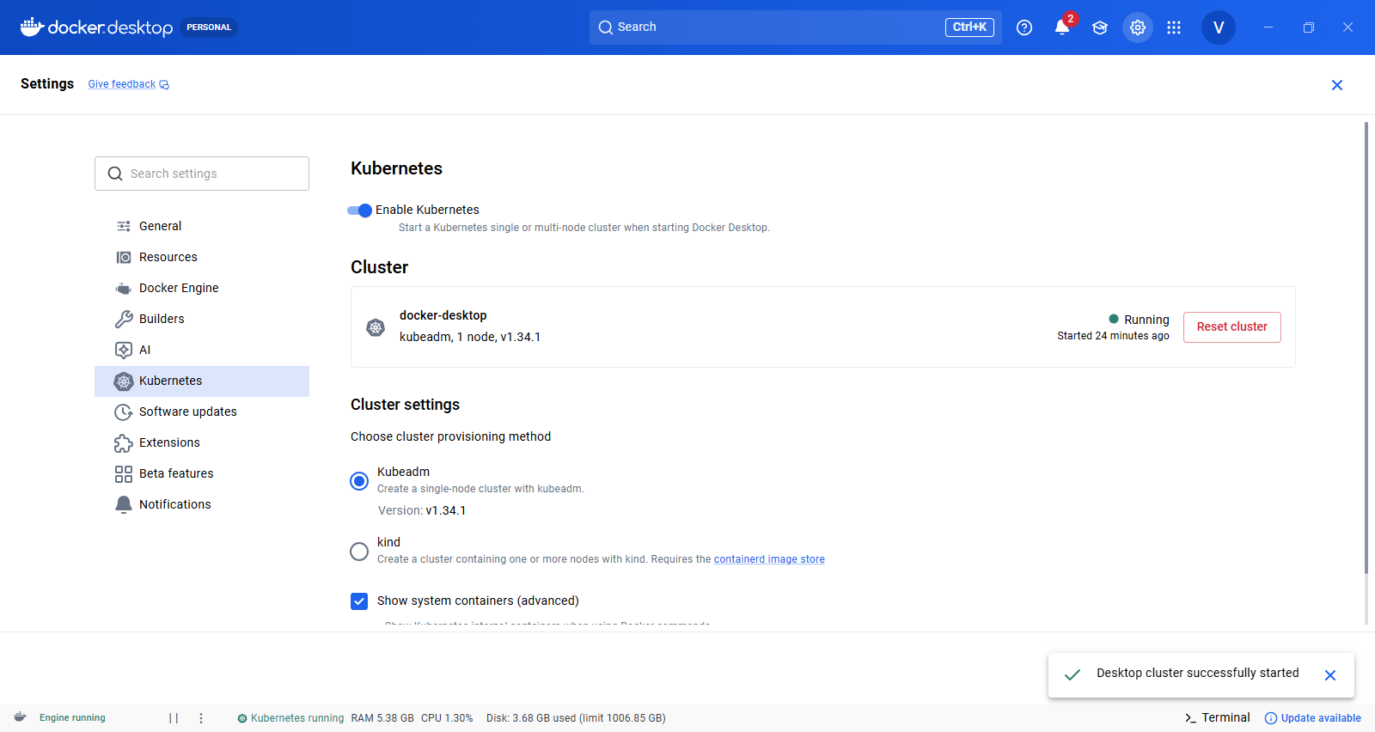

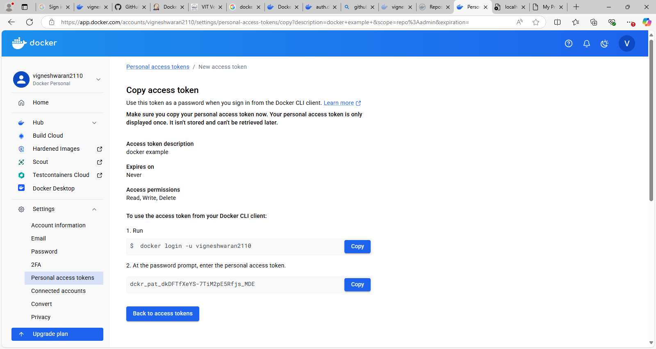

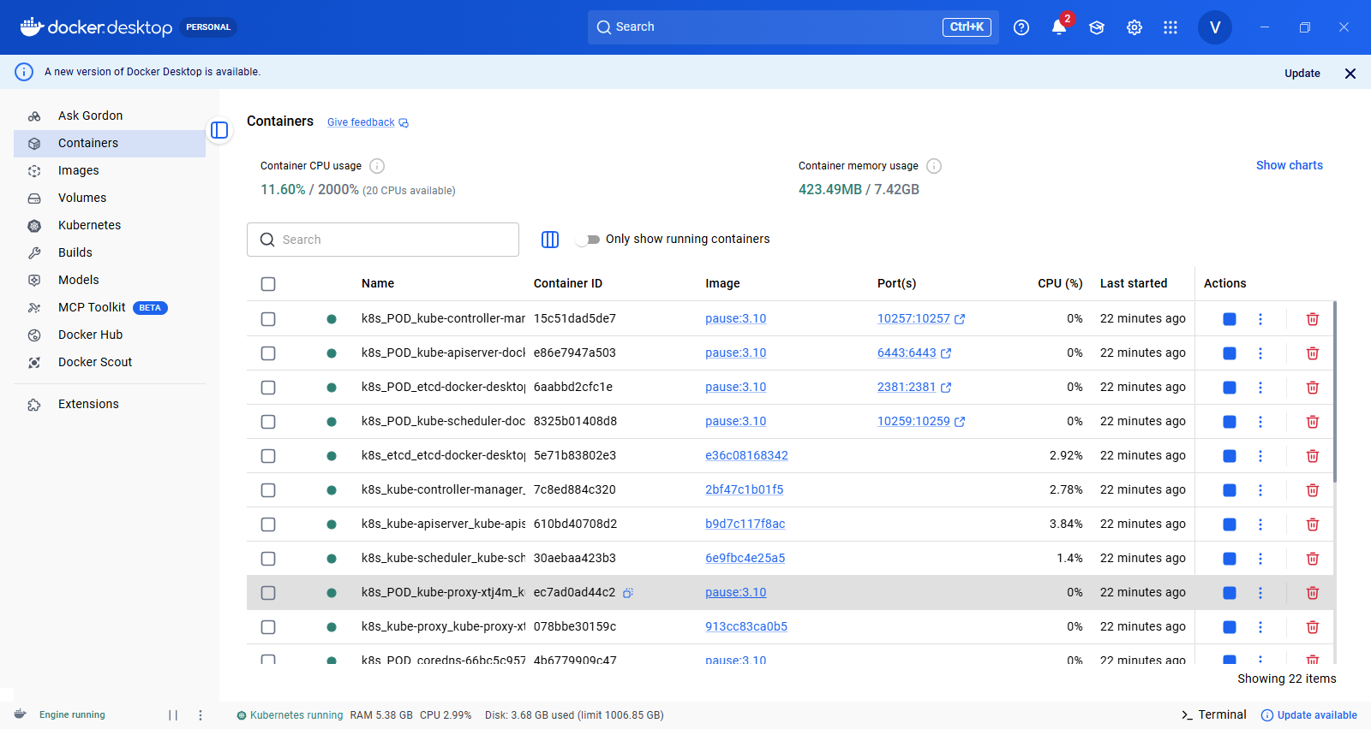

3. Open Jenkins In Jenkins

Setting --> Credentials New Credentials – User name: , password , ID:, Description

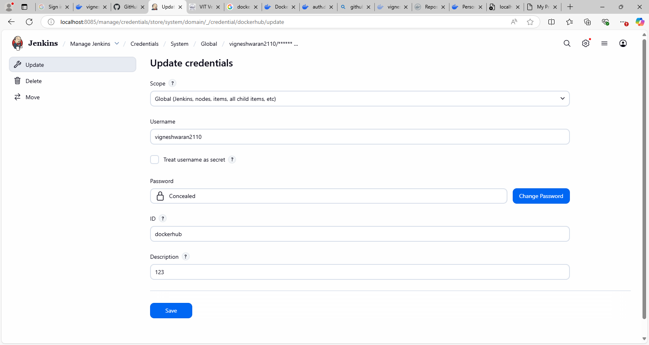

New Credentials – Secret – Broswse C: User->Administrator-->.kube

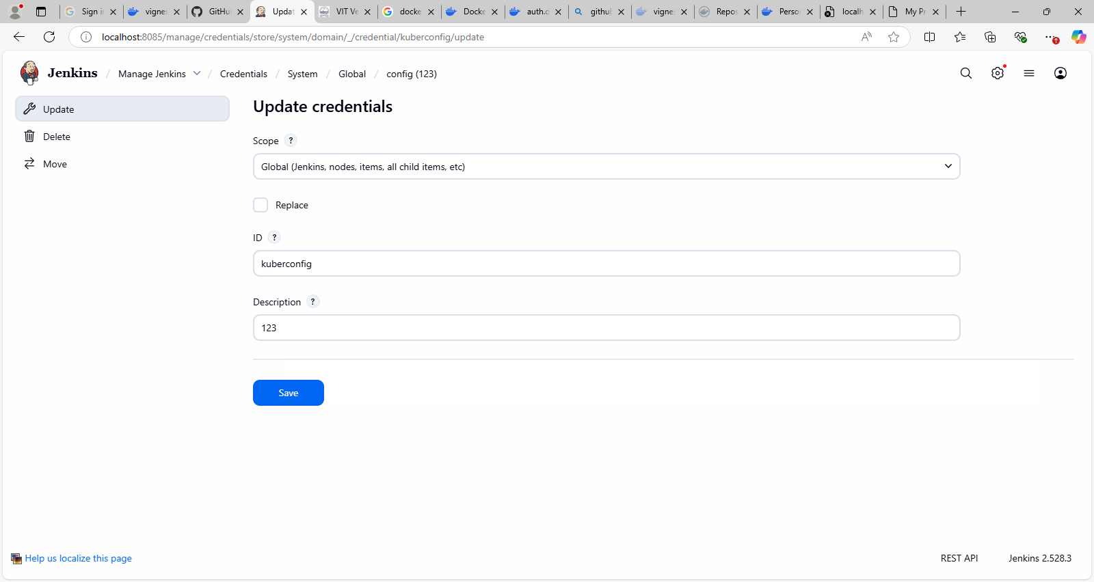

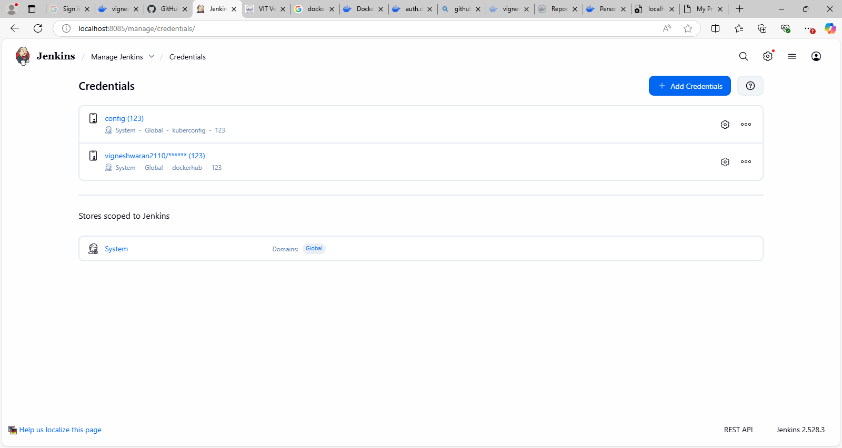

4. Create New Item -> Pipeline
Paste the code in pipeline script
- Update URL of GIT repository
- Make sure credentialsId: “dockerhub” same as mentioned in credentials
- Make sure that the ID mentioned in credentials “kuberconfig” is same as in script
- Run the Build
Pipeline:

pipeline {
agent any
environment {
DOCKER_IMAGE = "vigneshwaran2110/html-demo"
}
stages {
stage('Clone Code') {
steps {
git branch: 'main',
url: 'https://github.com/vigneshwaran21-vicky/docker-example.git'
}
}
stage('Build Docker Image') {
steps {
bat 'docker build -t %DOCKER_IMAGE% .'
}
}
stage('Push Image') {
steps {
withCredentials([usernamePassword(credentialsId: 'dockerhub',
usernameVariable: 'USER', passwordVariable: 'PASS')]) {
bat 'docker login -u %USER% -p %PASS%'
bat 'docker push %DOCKER_IMAGE%'
}
}
}
stage('Deploy to Kubernetes') {
steps {
withCredentials([file(credentialsId: 'kuberconfig', variable:
'KUBECONFIG')]) {
bat '''
set KUBECONFIG=%KUBECONFIG%
kubectl apply -f deployment.yaml --validate=false
'''
}
}
}
}
}

OTUPUT:-
